HIV/AIDS History and PrEP/PEP Research From a Female Perspective
Claire Lapat

Abstract
HIV arrived in the United States in 1981. Since HIV research began, HIV studies have neglected women. The majority of HIV patients in the United States in the early 1980s were gay men, making it unsurprising that initial HIV research did not include women. Since the group at highest risk of HIV infection were gay men, AIDS was first dubbed as GRID or Gay Related Immunodeficiency. The history of calling AIDS, GRID, has prolonged neglect of many groups who are exposed to the HIV virus. During the 1980’s outbreak of HIV in the United States, four groups of people were labeled most at risk of contracting the HIV infection: homosexuals, heroin users, hemophiliacs, and Hattians. Women have never been taken into consideration during talks and/or studies about the prevalence of HIV. In 1987, antiretroviral therapy was first introduced to slow the progression of HIV and prevent full-blown AIDS. that Unfortunately the focus on AIDS as a male disease has never fully shifted, and this has led the study of antiretroviral therapies to be studied predominantly in male-bodied people. Antiretroviral therapies can have severe adverse side effects including but not limited to kidney damage, bone loss, acute pancreatitis, and hepatitis B flare ups (in people with HBV). These side effects can have lasting consequences on a person’s health. The goal of this paper is to delve deeper into antiretroviral therapy drug trials and the sample that was used to explore the possibility that antiretroviral therapy affects femme-bodied people differently than male-bodied people.

Methods and Findings
To acquire the data and information necessary for this paper, I reached out To Dr. Sharon Achilles at Magee Women’s Hospital of the University of Pittsburgh Medical Center, and Dr. Michael Root of Thomas Jefferson University Hospital. Both were able to give me some insight into their research. Dr. Achilles focuses her research on HIV in women and immune cells in the female genital tract. Dr. Root’s research is focused around HIV vaccine research. To supplement the information I was given by the doctors, I conducted searches in PubMed, the Pitt Health Sciences Library, and JSTOR.
In writing this paper, PrEP and PEP clinical trials and the effects of these medications on femme-bodied persons, was explored and dissected. Women represent half of the global population of people living with HIV, however, in clinical trials, women represent one in five of participants. This disproportionate number of women has greatly limited the information gained about how these drugs affect women. Clinical trials are an important tool to test safety and efficacy of new drugs. PrEP (pre-exposure prophylaxis) and PEP (post-exposure prophylaxis), are designed to reduce the amount of HIV in a person’s system to prevent the virus from attacking CD4 cells. CD4 cells are specialized immune cells that attack pathogens trying to enter a person’s body. The lack of CD4 cells leaves a person at a high risk of infection. PrEP and PEP clinical trials have led to important discoveries such as that treating HIV+ women with medication to reduce viral load reduces the chance of a woman passing HIV to the fetus. This was done not for the benefit of the woman but for the benefit of the baby. The woman was taken off medication once the baby was born. This is part of the historical neglect of women from PrEP/PEP clinical trials and treatment. It was thought that only women who were IV drug users, in the sex industry, or thought to be “promiscuous” contracted HIV and thus brought HIV on themselves. Research discovered, however, that almost eighty percent of HIV+ women contracted the virus via heterosexual contact. Any person who engaged in IV drug use is at a heightened risk of contracting HIV through needle sharing and all people who partake in drug and alcohol use are more likely to make decisions that lead to their participation in high-risk activities.
HIV/AIDS was originally thought to be a “gay male” disease, today in the United States, the most at-risk group is women living in poverty. HIV poses a persistent threat to women, especially women of color. In 2001, according to the Centers for Disease Control, HIV infection was the leading cause of death for African American women aged twenty-five to thirty-four years old. Poverty is also a risk factor of sexual inequality which is a lead cause of HIV infection in women, especially women of color. Young women of color, between the ages of fifteen and twenty-four, are more likely to experience sexual inequality in relationships and intercourse. In a Centers for Disease Control study which involved young women and girls in urban, low-income high schools, their first sexual experience occurred at a younger age than white young women in more affluent school districts. The age disparity between young women of color and young white women and their sexual partners was much greater. The incidence of sexual abuse, sexual assault, and intimate partner violence amongst women ages fifteen to twenty-four is the highest for any age group.
In a study conducted by Blanco et al, in Spain, their abstract starts, “Gender-specific data on the management of HIV infection are scarce”. The study conducted by Blanco et al reveals that in men and women less than or equal to fifty, their immunological response is worse than individuals over than fifty. Blanco et al concluded that this phenomenon was more profound in men than women. The study did not include the percentage of female subjects in comparison with the percentage of male subjects and thus, the study cannot prove that the results are statistically significant. This is a common trend with HIV studies that claim to look at women. Many do not disclose their proportions of males versus females. An ongoing study being conducted by EuroCord Cohort Collaboration concluded, “Global variations in short-term and long-term mortality among WLWH initiating ART may inform context-specific interventions”. This conclusion essentially means that prescribed ART medicines must be prescribed within the context of a person’s life. This preliminary data is not very informative but reinforces the sentiment that more research into sex differences in HIV and response to ART must be studied.

Figures
Figure 1
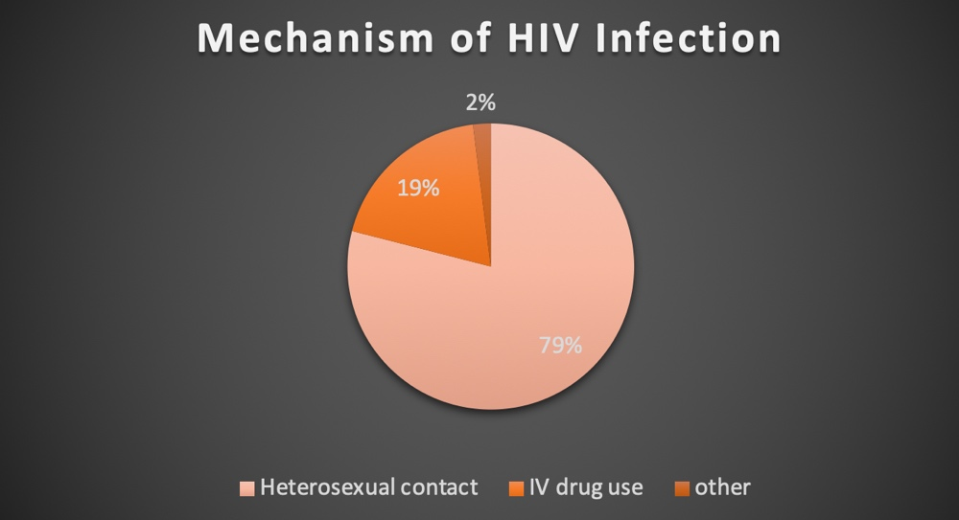

Figure 2
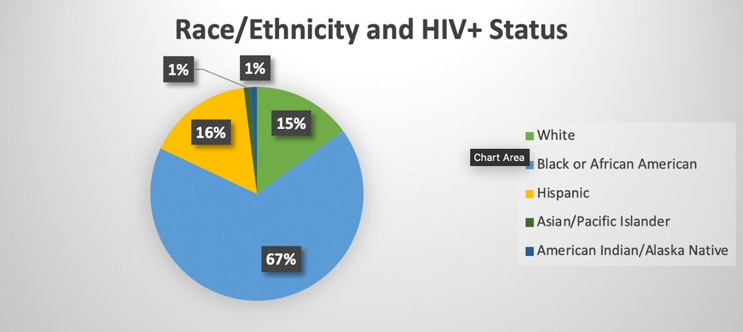

Figure 3
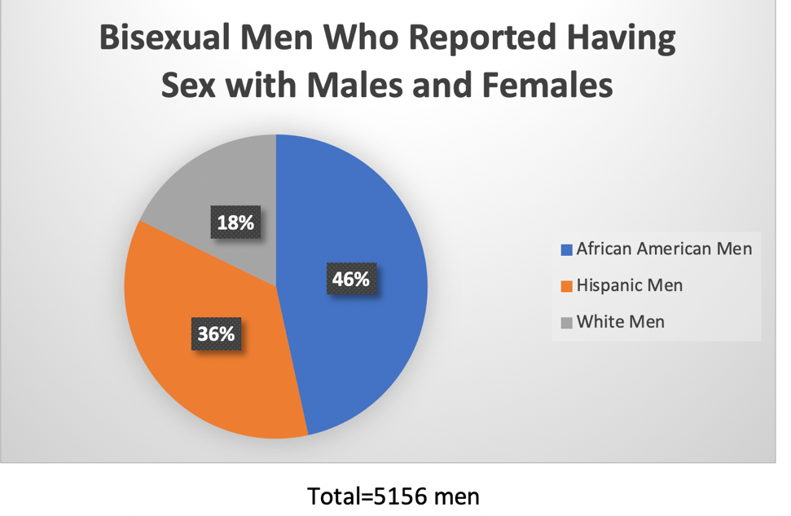
Figure 4
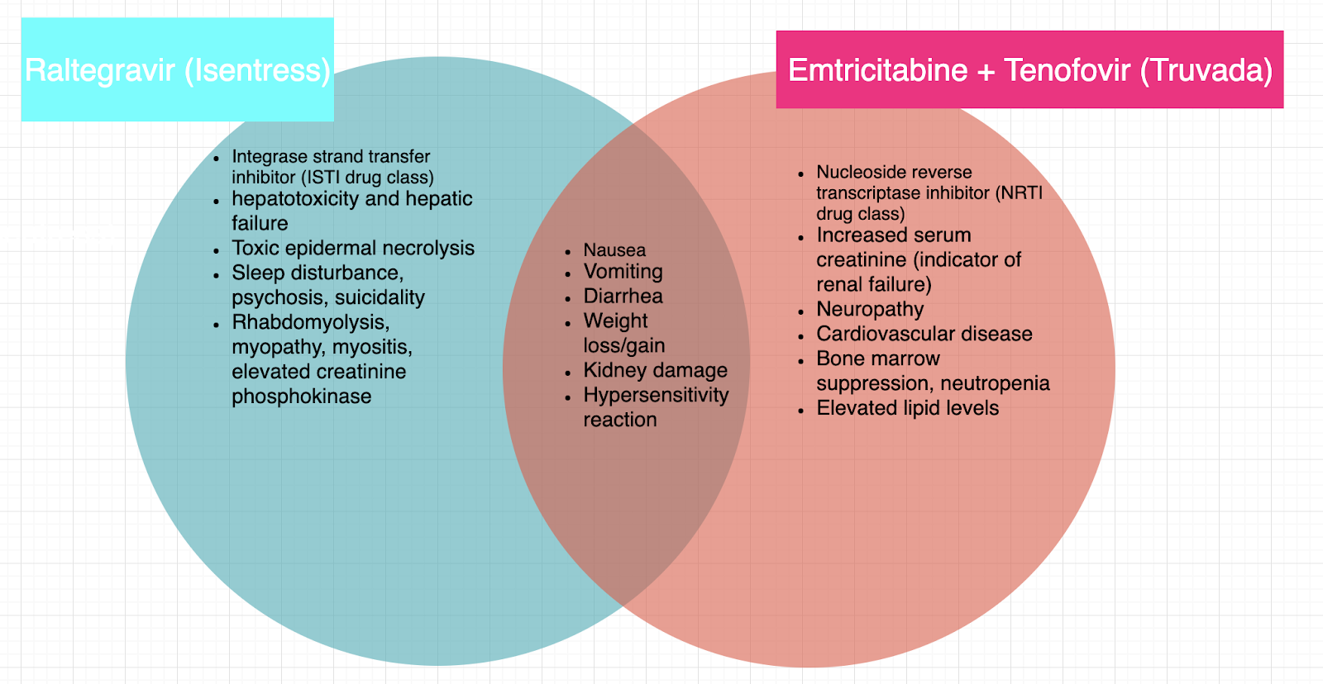

Conclusion
In conclusion, women are very much affected by HIV and are drastically underrepresented in clinical trials. There is little to no research being conducted to determine the safety and efficacy of Truvada, Isentress, Trivacay, and other PrEP/PEP drugs. PrEP/PEP have been linked to reductions in bone density and renal damage. Loss of bone density is a problem that is more common in women than men and can be exacerbated by medications such as Truvada. There is a possible connection between renal tubulopathy and osteomalacia. Figure 4 shows some of the confirmed side-effects of antiretroviral therapies that have a higher rate of occurrence in women. The long-term consequences of these side effects are unknown.
Figure 4 shows the medications that have the highest potency and are often recommended for anyone who needs to take PrEP or PEP. However, women are 12% less likely to be prescribed the most potent, effective, and safest drugs. The underlying sexism that is rampant in medicine is costing women their lives. In a study conducted by Dr. Stefano Vella at the Istituto Superiore di Sanitá in Rome, women were less likely to be prescribed medication with adequate drug potency. Treatment failure was seen in these women because other medications, even more potent ones, were unable to effectively lower their viral load. The percentage of women living with AIDS has been increasing 10% per decade, for the past two decades. This is a staggering statistic. HIV continues to be the leading cause of death globally for women of reproductive age. The best way to combat this is by making clinical trials more equitable. Many studies do not acknowledge women as subjects. It should be noted that Dr. Vella’s study is one of the few to address women. Women make up a very small percentage of research subjects and thus there is very limited data as to the safety and efficacy of antiretroviral therapies in women. It is known that hormones, especially estrogen, impact the immune system. Estrogen causes the immune system to repress HIV viral load. This is initially beneficial to the patient. However, in the long-term, this makes a patient’s HIV harder to treat. Women have also been observed to progress from HIV to AIDS almost twice as fast as their male counterparts. According to Dr. Sharon Achilles at Magee Women’s Hospital of the University of Pittsburgh Medical Center, there are underlying factors due to immune cells that lie within the female genital tract. HIV attacks lymphocytes and other HIV-prone immune cells that reside within the female genital tract. However, Dr. Achilles’’ research is an ongoing project and there are not conclusive results at this time.
Socioeconomic and social barriers to care are also a major contributor to the mortality and morbidity of HIV in women. The cost of medication must be lowered, and insurance companies must be required to cover ART drugs. Since adolescent and young adult women are one of the most at-risk populations, high schools should be required to teach sex education, including education about men who have sex with men, women who have sex with women, sexually transmitted infections, and proper contraception use. Condoms should also be made available to students. Condoms are the only contraceptive that protects against HIV transmission, if correctly used. According to Dr. Sharon Achilles at Magee Women’s Hospital of the University of Pittsburgh Medical Center, contraception availability is the best HIV prevention strategy from a public health standpoint. There is still a stigma surrounding HIV and the stigma must end. Stigma prevents many individuals from seeking care. Although more research is needed, the everyday person can help end the HIV epidemic by talking about it openly, talking about safe sex, and thus reducing stigma.

Acknowledgements
This research would not have been possible without the information provided by the Centers for Disease Control, The British Medical Journal, University of Pittsburgh Medical Center, Dr. Michael Root at Thomas Jefferson University Hospital, and the countless courageous women who participated in clinical trials and shared their stories. To conclude this paper, I want to recognize the millions of people, but especially women, who have died from HIV/AIDS or opportunistic infections due to their HIV status.

Citations

Achilles, Sharon L, Hillier, Sharon L. The Complexity of Contraceptives: Understanding their Impact on Genital Immune Cells and Vaginal Microbiota. AIDS Volume 27, Supplement 1, October 2013: S5-S15. doi: 10.1097/QAD.0000000000000058. PMID: 24088684. PMCID: PMC4012023.
Belluz, J. “The Truvada Wars.” Bmj, vol. 348, no. jun24 19, 2014, doi:10.1136/bmj.g3811.
Blanco, Jose Ramón, et al. “Combined Effect of Sex and Age in Response to Antiretroviral Therapy in HIV-Infected Patients.” Antiviral Therapy, vol. 22, no. 1, 28 July 2016, pp. 21–29., doi:10.3851/imp3071.
Centers for Disease Control. “HIV among Women.” PsycEXTRA Dataset, 2011, doi:10.1037/e553522012-001.
Centers for Disease Control. “HIV/AIDS Among Women Who Have Sex With Women.” PsycEXTRA Dataset, July 2006, doi:10.1037/e585422006-001.
IeDEA and COHERE in EuroCoord Cohort Collaboration. “All-Cause Mortality after Antiretroviral Therapy Initiation in HIV-Positive Women from Europe, Sub-Saharan Africa and the Americas.” Aids, vol. 34, no. 2, 1 Feb. 2020, pp. 277–289., doi:10.1097/qad.0000000000002399.
National Institutes of Health. “Guidelines for the Use of Antiretroviral Agents in Adults and Adolescents with HIV.” National Institutes of Health, U.S. Department of Health and Human Services, 2019, aidsinfo.nih.gov/guidelines/htmltables/1/7355.
N Engl J Med. 2012 Aug 2;367(5):411-22. doi: 10.1056/NEJMoa1202614. Epub 2012 Jul 11.
Vella, Stefano. “New Perspectives in Antiretroviral Therapy of HIV Infection.” Cytometric Cellular Analysis Cellular Aspects of HIV Infection, 2003, pp. 423–437., doi:10.1002/047122393x.ch21.

