Claire's PVSRIPO paper (02239808).DOCX

Claire Lapat
BIOSC 1010 Tuesday 2:00
Final Version
Introduction
Glioblastoma is one of the most aggressive malignant brain tumors with very few treatment options. The average length of survival for someone diagnosed with glioblastoma is eight months. Glioblastoma is unique because the tumor suppresses its microenvironment, leaving the immune system unable to generate any anti-tumor antibodies and making it easier for the tumor to invade new areas of the brain and spinal cord (Walton et al., 2018). CD155 exploits the immunosuppression of the tumor environment by enhancing tumor propagation, a phenomenon that is not fully understood. CD155 also leaves glioblastoma tumors susceptible to PVSRIPO. PVSRIPO is a genetically engineered poliovirus that has been weakened, or attenuated, by the addition of a foreign internal ribosomal entry site from human rhinovirus, the most common virus that causes the common cold. The genetically engineered virus is thus unable to cause inflammation of the central nervous system (Gromeier & Nair, 2018). This review aims to address the following central questions: (1) What are the oncolytic (destruction of cancer) and cytotoxic (toxic to cells) effects of PVSRIPO on glioblastoma tumors; and (2) what effects, if any, does PVSRIPO have on recruiting the host immune system to attack the cancer cells given the complexities of glioblastoma? Answering these questions will provide a deeper insight into the potential of using viruses to recruit the patient’s immune system to destroy cancer cells, which in turn could lead to lesser exposure to toxic chemotherapies and radiation treatments.
Poliovirus is infamous for causing death or disability in those who contracted the virus. Today, polio is practically nonexistent in the developed world due to vaccinations. In 1955 Jonas Salk released the first polio vaccine, made from an inactivated virus. Shortly after, Albert Sabin released a second vaccine using a live-attenuated virus. In the studies discussed in this review, the Sabin live-attenuated virus was used to develop the recombinant nonpathogenic polio-rhinovirus chimera (PVSRIPO). In 2004, Sloan et al, a research group out of Tuft’s Medical Center in Boston, published the first paper that drew connections between poliovirus and glioblastoma, one of the most aggressive and deadly cancers, through the CD155 receptor. CD155 is known as the poliovirus receptor. Sloan et al published their discovery that CD155 plays a role in tumorigenesis and cell motility in many types of cancer including glioblastoma. In 2012, the research into the connections between poliovirus and glioblastoma manifested into a clinical trial at Duke Cancer Institute. This review aims to delve deeper into the oncolytic and immunogenic effects of PVSRIPO and the unique features of glioblastoma that prevent other viruses from being able to have cytotoxic effects. This review also looks at connections between the cytopathogenic impacts of PVSRIPO due to CD155 reception, immunosuppression of the tumor microenvironment, and the recruitment of the host immune system by PVSRIPO to attack the tumor.
.
Lactic Acid Dehydrogenase as an Indicator of Tumor Cell Apoptosis
Lactic acid dehydrogenase (LDH) is an enzyme found in all cells that is released when tissues are damaged. Through an in vitro study, melanoma cell lines, which are well-known to express CD155, the poliovirus receptor, were pre-treated with interferon-α (IFN-α). IFN-α is an inflammatory molecule, also known as a cytokine, that the innate host immune system produces to defend the host against viral infections. The pre-treated cells were then infected with the engineered poliovirus PVSRIPO (Walton et al., 2018). LDH is released when cells are damaged and thus the percent of cytotoxicity can be determined by measuring LDH levels at different time intervals. Walton et al (2018) used melanoma cells because they are more established in the literature to be abundant in CD155, allowing more cell lines to be tested. The cytotoxicity observed from PVSRIPO was retained at low MOIs (multiplicities of infection) and the virus remained competent in the presence of type I interferons, either added in vitro or from the host cell’s innate immune system response. Experimenting with different MOIs is important because this can help determine the viral load in a dose, and it is ideal to use a dose containing the lowest possible MOI. Retention of cytopathogenicity was predicted to be a unique feature of PVSRIPO, and to test this, Walton et al. tested encephalomyocarditis virus (ECMV) against PVSRIPO. Type I IFNs, which include IFN-α, IFN-β, and IFN-α2α, cause changes to the innate antiviral responses in host cells through paracrine-STAT1 (p-STAT1) phosphorylation (Walton et al., 2018). P-STAT1 in DM440 cells treated with IFN-α2α increased after the cells were infected with PVSRIPO or EMCV. IFN-α2α was able to outcompete EMCV and killed the virus, eliminating EMCV as a treatment option. In contrast, IFN-α2α had no effect on PVSRIPO propagation within the tumor. The differences that were seen (Figure 1) between PVSRIPO and EMCV in the presence of type I IFNs yielded more questions about other innate immune cytokines that PVSRIPO could resist.

PVSRIPO Evasion of the Innate Immune System is a Unique Characteristic of the Virus
Most immunotherapies recruit the host’s innate immune system to produce tumor-antigen-specific anti-tumor immunity. Glioblastoma immunosuppresses the tumor microenvironment and therefore the host innate immune system cannot be recruited by typical immunotherapies used to treat other forms of cancer. PVSRIPO can evade IFN-α2α (figure 2A), a component of the innate immune system that is supposed to promote natural-killer cell and cytokine responses to viral infections as well as promote antigen presentation. EMCV was rapidly destroyed by the innate immune response generated by the host, but PVSRIPO was not only able to evade the innate immune response, but it destroyed the innate immune response by cleaving eukaryotic translation initiation factor 4 (elF4G), a protein that is responsible for docking initiation factors and proteins involved in RNA translation (Walton et al., 2018). DM440 cells, derived from melanoma, have an intrinsic IFN response to PVSRIPO. DU54 cells, derived from glioblastoma, do not. DU54 cells were pre-treated with type I IFN and after twenty-four hours, were infected with PVSRIPO. Initially, the DU54 cells were delayed in their cleavage of elF4G, but after six hours post-infection, PVSRIPO was able to fully overcome the type I IFN pre-treatment and replicated just as well as the PVSRIPO that infected cells that had not been exposed to type I IFN (Figure 2b). This phenotype could be the result of the internal ribosomal entry sites used for viral replication and the ability of poliovirus to hijack cellular metabolic proteins and rearrange them to help propagate the poliovirus (Leveque & Semler, 2015). This can be done through viral proteins promoting GTPases, which catalyze the formation of phosphatidylinositol-4-phosphate, a lipoprotein that regulates membrane trafficking in the Golgi body. Phosphatidylinositol-4-phosphate is essential to the replication of poliovirus. In conjunction with the destruction of elF4G, and the hijacking of host cells to form phosphatidylinositol-4-phosphate, PVSRIPO can overcome or evade the innate host immune response generated by type I IFNs.

CD155-Mediated Immunoregulation Leads to Tumor Proliferation
CD155 is an immune checkpoint, but glioblastoma tumor cells can subvert the checkpoint or manipulate receptors to be able to prosper and grow within patients. The tumor microenvironment contains large amounts of myeloid-derived suppressor cells and regulatory T-cells and regulatory B-cells (Lee-Chang et al., 2019). These cells are responsible for the production of immunosuppressive cytokines such as transforming growth factor beta (TGFβ) and interleukin-10 (IL-10). In glioblastoma tumors, regulatory B-cells are immunosuppressive towards CD8+, a natural killer T-cell and key component of the immune system, due to the inhibitory effects of CD155. Many cancer immunotherapies utilize natural killer cells. If these cells are being suppressed by CD155, however, the treatment will not be effective. Figure 3 illustrates the CD155-mediated pathway on natural killer cells. CD155 in tumor-associated macrophages is also coregulated with PD-L1 (programmed death ligand 1), a membrane protein that acts as an immunoregulatory pathway (McKay et al., 2021). A persistently active aryl hydrocarbon receptor is responsible for this relationship. Aryl hydrocarbon receptors are a transcription factor best known for toxicity mediation (Torti et al., 2021). Evidence of the immunomodulatory role of aryl hydrocarbon receptors in glioblastoma macrophages is the prominent involvement of aryl hydrocarbon receptors in tumor-associated macrophages and the role of aryl hydrocarbon receptors in inflammatory pathways of glial cells in the central nervous system. When glioblastoma tumor cells were treated with SR1, an aryl hydrocarbon antagonist, the cytokine and inflammatory phenotypes of the cells shifted to become proinflammatory, inhibiting macrophage activation (McKay et al., 2021). This shows that CD155 and aryl hydrocarbon receptors both stimulate tumor progression and that aryl hydrocarbon receptors play a role in controlling CD155 and PD-L1 expression in tumor-activated macrophages. These receptors promote tumor survival by altering two immune checkpoints, contributing to the immunosuppression of the tumor microenvironment. CD155 activates the T-cell immune receptor with Ig and ITIM domains (TIGIT) and PD-L1 activates programmed cell death protein 1 (PD-1). Both pathways control immune cell effector function. PD-1 down-regulates the immune system by suppressing T and B-cells while creating a more favorable environment for itself by reducing inflammation from T-cell response. TIGIT is responsible for tumor recognition by B-cells and T-cells and limits the ability of the host to activate innate and adaptive immune systems. CD155 is at the center of the immunosuppression and immunomodulation of the tumor microenvironment and causes the lack of host immune response to glioblastomas, allowing glioblastomas to progress rapidly.
CD155 thus, promotes the growth and invasiveness of glioblastoma. Increased levels of CD155 showed more cell migration and invasion into new parts of the central nervous system by glioblastoma due to the ability of CD155 to promote cell adhesion through the activation of tyrosine kinases (Lupo & Matosevic, 2020). Phosphorylation of tyrosine kinases initiates the breakdown of focal adhesions through activation of its cytoplasmic tail, and thus allows tumor migration by adhesion turnover, favoring the tumor. Sloan et al. also found that when CD155 is recruited to the leading edge of migrating cells, interactions occur with actin and αv-integrin. Actin is a globular protein that forms microfilaments, giving cells support and motility abilities. Integrins are transmembrane receptors that can facilitate adhesion between cells and adhesion between a cell and the extracellular matrix. The interaction between CD155, actin, and αv-integrin is strong evidence of the role that CD155 plays in glioblastoma adhesion and motility. To truly understand the effects of CD155 on tumor motility, Sloan et al. tested the abilities of CD155 knockouts. CD155-specific monoclonal antibodies were fused to a human IgG (immunoglobulin G) backbone, simulating the tumor host. Fluorophore-assisted light inhibition (FALI) of CD155 significantly inhibited cellular migration by 20-23% (Sloan et al., 2004). To further validate the findings that CD155 is extremely important for cell motility and proliferation, Sloan et al. developed a siRNA (small interfering RNA) complex, which is a non-coding strand of RNA, to target CD155 mRNA, resulting in protein inactivation and yielding a CD155 knockdown. The CD155 knockdown was able to destroy 90% of CD155 protein at 72 hours post-infection. There was also a 23% decrease in migration in the cells transfected with siRNA versus the control cells. These experiments were conducted with CD155-positive fibrosarcoma cells. To prove that these results would hold true in glioblastoma cells, FALI was used to knock down CD155 protein in U87MG glioblastoma cells. Loss of CD155 in U87MG cells resulted in a 16-22% decrease in cellular migration (Sloan et al., 2004). Loss of function when CD155 is removed is indicative of CD155 playing an essential role in tumor proliferation and motility. The loss of motility is likely due to the disruption in the tumor’s ability to adhere to and thus hijack host central nervous system tissue.

Cytotoxicity and Activation of Host Immune System by PVSRIPO
As aforementioned, glioblastoma suppresses the immune system in its environment, acting as a shield to protect the tumor from the host’s immune system, and making it easier for glioblastoma cells to replicate and spread. PVSRIPO is administered intratumorally and is received by CD155, the poliovirus receptor which allows PVSRIPO to trigger an immune response from dendritic cells. This immune response is a pro-inflammatory response that results in a tumor-antigen presentation and thus inducing a response from antitumor cytotoxic T lymphocytes (Brown et al., 2017). Neutrophils, a type of white blood cell that plays a large role in fighting viral infections, are then recruited to the tumor microenvironment. The presence of neutrophils in the tumor microenvironment reduces the immunosuppression that is caused by glioblastoma. The immunosuppression of the tumor microenvironment leaves host tissue susceptible to glioblastoma growth. As PVSRIPO replicates within the tumor, viral proteases are released, damaging elF4G in tumor cells, and leading to the suppression of host protein synthesis (Brown et al., 2017).
Dendritic cells are forms of antigen-presenting cells that are activated by PVSRIPO infection. Activation of dendritic cells can initiate an adaptive immune response, especially because antigen-presenting cells are CD155-positive. As more dendritic cells are activated by PVSRIPO within the tumor, cytokines contribute to the pro-inflammatory response and tumor death (figure 4). Cytokine release is sustained because dendritic cells are not lysed by PVSRIPO, but viral translation is able to occur within dendritic cells (Brown et al., 2017). PVSRIPO demonstrates its durability and uniqueness in that it produces a robust type I IFN response in dendritic cells rather than viral cytotoxicity. The upregulation of many cytokines can result in autoimmune diseases. However, PVSRIPO directs the cytokine storm to localize at the tumor. Walton et al. observed that the greatest amount of viral translation and cytotoxicity was positively correlated with the greatest STAT1 response (Walton et al., 2018). In figure 1, the percent cytotoxicity based on LDH release is graphed and supports the findings of Brown et al. PVSRIPO localizes the cytokine storm to the tumor because the virus cannot replicate outside of glioblastoma cells due to the formation of a ribonucleoprotein from rhinovirus internal ribosome entry site mediating the neuro-attenuation of poliovirus. In other words, the genetic information responsible for the devasting effects of poliovirus is replaced with the human rhinovirus internal ribosomal entry site. Ribosomes are essential for converting RNA to proteins, thus preventing neurovirulence when glioblastoma tumors are inoculated with PVSRIPO. This not only provides biosafety, but also localizes cytokine storm to the tumor, preventing an autoimmune response in the patient and causing oncolysis.

Glioblastoma Hijacks Immunometabolic Pathways
Glioblastoma cells are metabolically distinct from healthy central nervous system tissue (Mohan et al., 2021). Many of the impacts of glioblastoma would be impossible without its ability to regulate the immunometabolism of the surrounding host tissues. Two ways that immunometabolism is changed by glioblastoma that are most relevant to this review are the induction of a hypoxic environment and the disruption to adenosine metabolism. Hypoxia of the tumor microenvironment contributes to its immunosuppression. Hypoxia occurs due to how quickly glioblastoma grows. The tumor must oxygenate itself through the development of its own vasculature, a phenomenon called tumor angiogenesis. The surrounding host tissue becomes necrotic due to hypoxia, leading to hypoxia-induced factors which signal tumoral angiogenesis (figure 5). The upregulation of hypoxia-induced factors is one of the ways in which glioblastoma resists conventional treatments. For example, bevacizumab is a chemotherapeutic medication, synthesized from monoclonal antibodies that targets vascular endothelial growth factor, a byproduct of the production of hypoxia-induced factors. Bevacizumab can also induce hypoxia resulting in autophagy, leaving the host defenseless against tumor angiogenesis (Mohan et al., 2021). Hypoxic conditions cause glioblastoma to upregulate interleukin-6 and interleukin-8, both of which act as autocrine proliferative agents and contribute to tumor growth and the tumor’s vascular development (Mohan et al., 2021). IL-6 also upregulates PD-L1, which is co-expressed with CD155 (figure 4). The upregulation of CD155 causes the upregulation of vascular endothelial growth factors, stimulating tumor angiogenesis (Zhan et al., 2022).
Hypoxia can disrupt adenosine metabolic pathways via hypoxia-induced factors by causing it to be trafficked into the extracellular matrix, stimulating the upregulation of tumor angiogenesis. Adenosine metabolism is essential to produce ATP, an energy source that drives many cellular functions under non-malignant conditions. Extracellular adenosine contributes to tumor proliferation and weakens innate and adaptive immune responses (Ott et al., 2020). Neutrophilic responses are inhibited by extracellular adenosine. Therefore, neutrophils are unable to adhere to and attack the glioblastoma, nor can they release TNF-α, one of the main components of the host’s adaptive immune system fighting against glioblastoma.
CD155 plays a role in immunometabolism by regulating the vascular endothelial growth factors which are triggered by the glioblastoma tumor creating a hypoxic environment. Hypoxia can cause adenosine metabolic pathways to traffic adenosine to the extracellular matrix, further exacerbating this lethal cycle. PVSRIPO can evade and alter the innate immune responses that have already been hijacked by glioblastoma, most notably type I IFNs, STAT1, and NF-κB. The hypoxic state created by glioblastoma creates a disordered, pro-tumor cytokine storm. PVSRIPO localizes the cytokine storm, controlling the chaos of a pro-inflammatory response.

Discussion and Conclusion
The use of PVSRIPO infused intratumorally into glioblastomas provides hope for a form of cancer that generally is treatment-resistant and results in a patient’s death within a matter of months. CD155 is only starting to be understood beyond its role as the poliovirus receptor. This review sought to answer questions about the cytotoxic and oncolytic effects of PVSRIPO and how PVSRIPO interacts with the host’s immune system. Many forms of solid-tumor cancers, including glioblastoma, have an abundance of CD155 which lead to the hypothesis that CD155 played a role in tumorigenesis (Sloan et al., 2004). CD155 has been found to play many roles in the lethality of glioblastoma because it plays a role in turning every innate protection against tumors into agents for tumor proliferation and motility, as well as the corruption of the host’s innate immune system.
In vivo and in vitro studies using CD155-positive malignancies demonstrated that CD155 is a ligand for many innate immune responses, with glioblastoma, immunosuppression of the tumor microenvironment likely driven by CD155 (Desjardins et al., 2018). The exploitation of the immunosuppressed tumor microenvironment is facilitated by CD155, which intrinsically alters the innate immune system of the host to propagate glioblastoma growth. CD155 usually acts as an inhibitory ligand, but in malignancies, it is excitatory due to aryl hydrocarbon receptors. Tumor-associated macrophages are controlled by aryl hydrocarbon receptors, making them vulnerable to being hijacked by glioblastoma. In most tumors, tumor-associated macrophages are part of the host’s innate immune response and attempt to fight against the tumor (Mohan et al., 2021).
A disease as unique and personal as glioblastoma is incredibly hard to treat. The unique phenotypes of PVSRIPO, which allow the virus to thrive in an environment usually detrimental to viral replication, can overcome the complexities of glioblastoma. Both poliovirus and encephalomyocarditis virus (EMCV) are members of the same viral family, and they were both tested against type I IFN activation in vitro to determine if PVSRIPO has unique characteristics. Type I IFNs produce an innate anti-viral response. PVSRIPO was able to evade the type I IFN response, and there was no significant difference between PVSRIPO replication in cells pre-treated with IFN, and the control (figure 2) (Walton et al., 2018). In contrast, EMCV succumbed to cells pre-treated with IFN. The ability of PVSRIPO to evade the host’s innate immune response is invaluable for future immunotherapies.
Unlike many of the cytokines discussed in this review, the endogenous function of CD155 is still unclear. Studies show that it is a glycoprotein and ligand with inhibitory and excitatory properties. It is unclear why CD155 is so much more abundant in malignant cells in comparison to healthy cells. One explanation could be that malignancies can arise from mutations in DNA or RNA strands that code for CD155 production. To confirm this, genetic sequencing would have to be performed on control subjects and patients with CD155-positive tumors. It would also have to be determined if the full exome would be sequenced or sequencing of a biopsied tissue sample would be sequenced.
Future research into the use of PVSRIPO should include cell lines from diffuse intrinsic pontine glioma (DIPG), a form of childhood cancer with a 0% survival rate. Many glioblastoma patients can undergo surgery to resect parts of their tumors. According to the Dana-Farber Cancer Institute at Boston Children’s Hospital, surgery is not an option for DIPG patients because the tumor is located within the brainstem. Radiation and steroids are sometimes used to manage symptoms from tumor growth, yet no child has survived DIPG to date and fewer than 10% live beyond two years. There is preliminary research into the possibility of CD155 presence in DIPG tumors (Tzaridis et al., 2022). Testing PVSRIPO in DIPG cells, using techniques outlined by Walton et al (2018) may progress DIPG treatments and hopefully help children to survive. A barrier to this research is the lack of funding for childhood cancer research and the current research into treating DIPG thus far has not been encouraging (Izquierdo et al., 2022). Viral immunotherapies are the future of cancer treatments. They require the patient to undergo little to no chemotherapy and radiation, both of which have long-term health consequences. The results of the studies reviewed have the potential to inspire more exploration and experimentation with viruses and their receptors and how that correlates with human diseases.

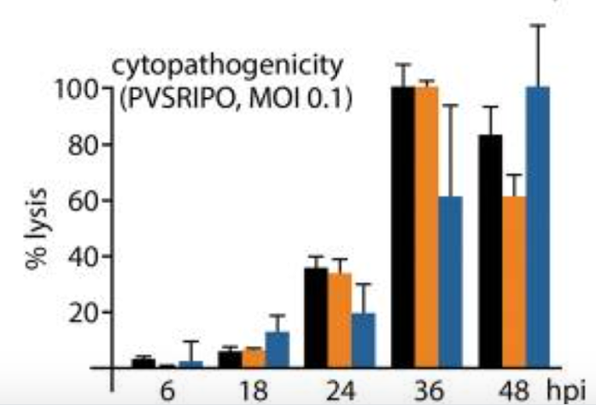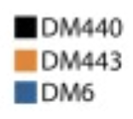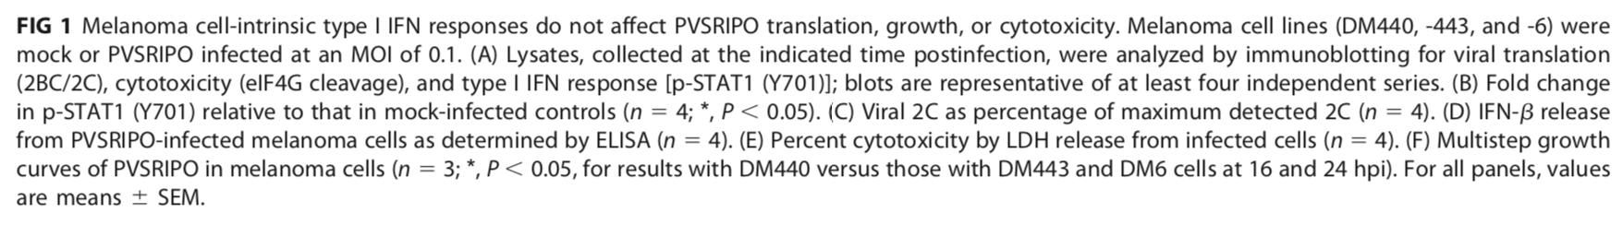
MOI (multiplicities of infection)

Figure 1: Lactic acid dehydrogenase (LDH) is released from cells during apoptosis and is a good indicator of cellular and tissue damage. It would be expected that cellular damage would occur in all cell lines by interferon type I because type I IFNs are known to respond to viral infection and can generate anti-tumor antigens. Melanoma cell lines, DM440, DM443, and DM6, which are well-known to express CD155, the poliovirus receptor. The cell lines were then split into experimental and control groups in which the experimental groups were pre-treated with IFN-α, due to its known innate anti-viral abilities. Experimental groups were then infected with the engineered poliovirus, PVSRIPO. The percent of cytotoxicity was determined by measuring LDH levels at different time intervals. Based on LDH levels, 100% cell lysis is observed in DM440 and DM443 cell lines at 36 hours post infection. DM6 experiences 100% cell lysis at 48 hours post infection with PVSRIPO (Walton et al., 2018). This finding is significant because it shows that PVSRIPO was able to overcome the innate anti-viral mechanisms of IFN-α, suggesting that PVSRIPO can withstand the innate immune response of a human host.

Figure 2: PVSRIPO was tested side-by-side with encephalomyocarditis virus (EMCV). Both PVSRIPO and EMCV are picornaviruses, and thus their responses to type I interferons was compared.

(A) CD155-positive cell lines were pre-treated with interferon-α as mentioned above. Cells were then infected with either PVSRIPO or EMCV to test if either virus had cytopathogenic effects which would cause a decrease in the titer of cells seen over a period of 48 hours post infection. The mean fold titer reduction of the virus within a cell pretreated with IFN-α was plotted and at 24 hours, there was a 12-fold decrease in EMCV titer. At all of the time intervals, the titer of PVSRIPO was not significantly impacted (Walton, Brown, Sacco, & Gromeier, 2018).

(B) PVSRIPO replicates at very low MOIs while retaining cytotoxicity. The cells remain competent even in the presence of an active IFN I response from host-cell, indicating that independence between PVSRIPO activity and MOI >=0. The retention of cytotoxicity in the presence of IFN-α is demonstrated in this figure by looking at how many plaque-forming units (pfu) per cell by PVSRIPO are present at 6, 18, 24, and 30 hours post infection. As hours post infection increased, the difference in plaque-forming units in samples pre-treated with IFN-α versus samples not pre-treated with IFN-α became statistically insignificant. This shows that PVSRIPO can avoid destruction by IFN-α, an important member of the host’s innate immune system to fend off viruses. This further supports the data seen in figure 2A as PVSRIPO does not appear to be impacted by IFN-α, however, ECMV is overpowered by the anti-viral abilities of IFN-α (Walton et al., 2018).

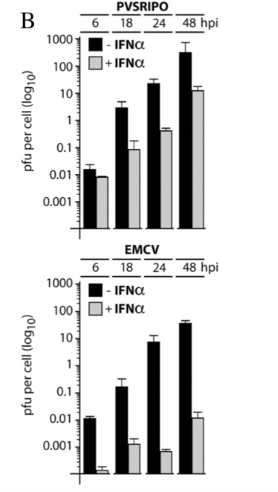
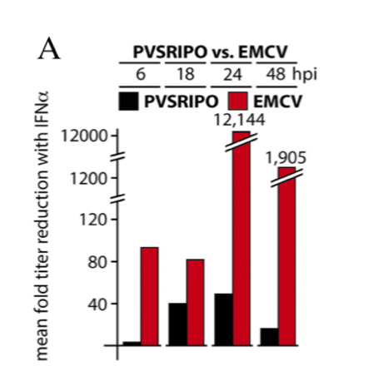
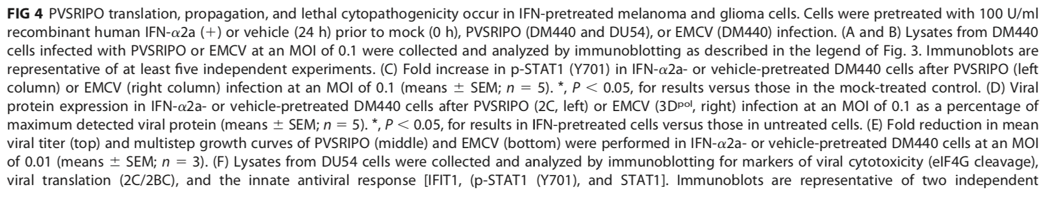

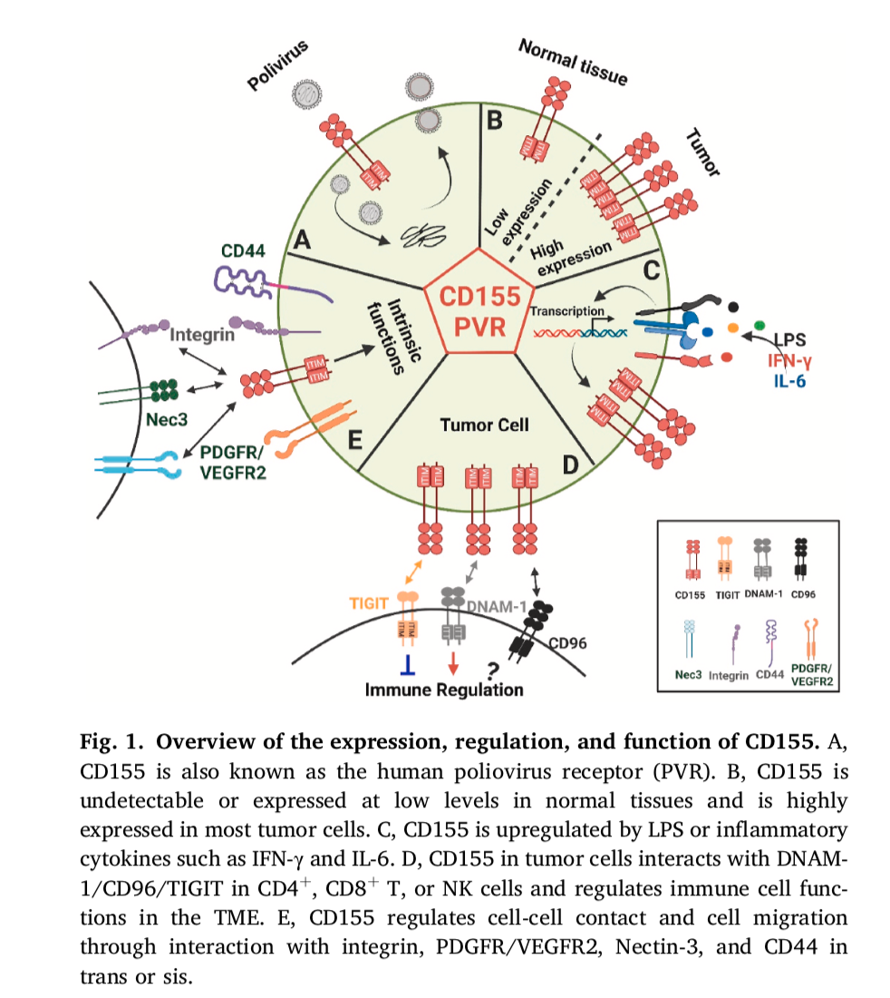(Zhan et al., 2022)
Figure 3: CD155 was discovered as the poliovirus receptor, but as immunotherapies for malignancies has progressed, CD155 has been found in abundance in tumor cells while it is practically undetectable in healthy tissue. The endogenous function of CD155 is not fully understood, but this figure attempts to provide a visual of what is understood so far about the abilities of CD155. In section A of this figure, the figure shows how poliovirus is received by CD155 and how poliovirus uses CD155 to replicate itself. Section B compares the difference in CD155 abundance in normal, healthy tissue and malignant tumors. CD155 is present in both, but it is present at much higher levels in malignant cells. It is unclear if the figure is proportional to the fold increase of CD155 in tumors. Section C shows that inflammatory cytokines upregulate CD155 transcription in tumors. Section D shows that upregulation of CD155 results in CD155 acting as a ligand for TIGIT, DNAM-1 (an important mediator of effector functions in natural killer cells and T-cells), and CD96. The impact on CD96 is not yet known, but TIGIT acting on CD155 inhibits immune regulation while DNAM-1 acting on CD155 is excitatory of immune regulation. Exact immune regulation is not shown but likely DNAM-1 triggers an inflammatory cytokine storm that upregulates tumor propagation (Desjardins et al., 2018), (Lee-Chang et al., 2019). The intrinsic functions based on existing experimental data are shown in section E. These functions appear to be cell adhesion and motility (Sloan et al., 2004), and tumor development of their own vasculature to ensure blood supply (Mohan et al., 2021), (Torti, Giovannoni, Quintana, & Garcia, 2021), (McKay, Brown, & Gromeier, 2021).

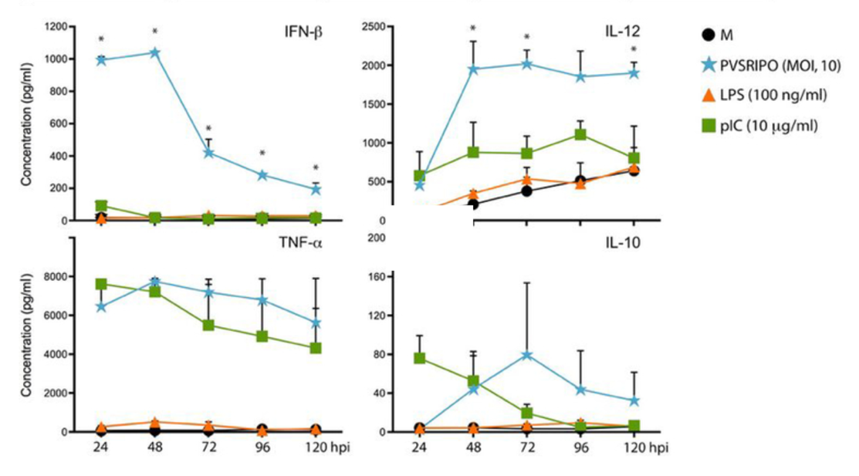
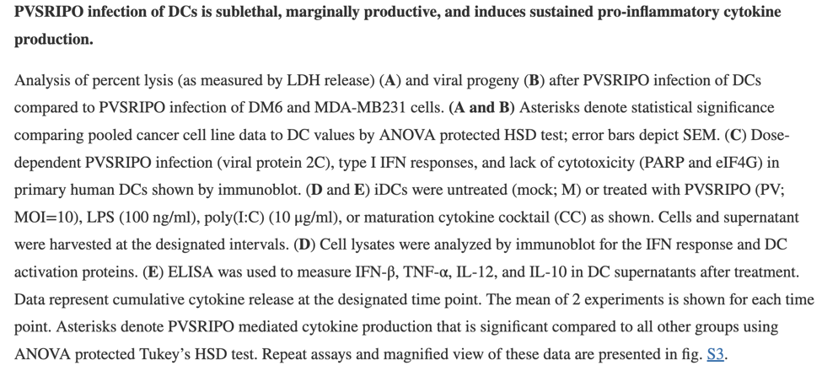
Figure 4: PVSRIPO triggers the release of pro-inflammatory cytokines when it infects dendritic cells (Brown et al., 2017). In this experiment, CD155-positive melanoma cell line DM6 was used as a positive control to compare dendritic cell infection. A negative control was also used. The cells were then infected with PVSRIPO. Cellular lysis was confirmed by measuring the LDH released. The pro-inflammatory cytokines IFN-β, TNF-α, interleukin-12, and interleukin-10 were collected by spinning down lysate to form a supernatant. The experimenters were then able to use ELISA (enzyme-linked immunoassay) to measure the levels of cytokines at multiple time intervals (hours post infection). IFN-β and interleukin-12 (IL-12) have the most statistically significant points. IFN-β has a very strong initial response to PVSRIPO, indicative of an innate immune anti-viral response. IL-12 started at low levels and then rapidly increased, before reaching a plateau, suggesting that IL-12 is an adaptive immune response and is activated by prolonged PVSRIPO exposure.

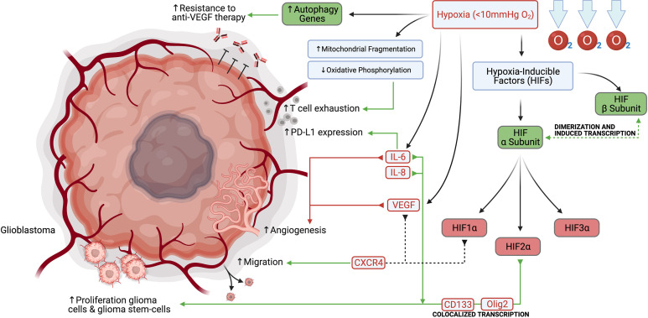
Figure 5: Hypoxia induced by tumors forming their own blood vessels impacts many immunometabolic pathways that contribute to increased tumor proliferation (Mohan et al., 2021). The pathways here provide a visual aid for readers in the complexity of some of these pathways, but it also shows how interconnected many of the pathways are. It is important to note here that PD-L1 is co-regulated with CD155 (Zhan et al., 2022). IL-6 upregulates PD-L1, which is part of the same pathway as the upregulation of tumor migration as a result of glioblastoma creating a hypoxic environment. PD-L1 and CD155 co-regulation may be important in this scenario and more tests should be conducted to see if CD155 control of adhesion and migration require presence of PD-L1 by creating a PD-L1 knock out cell strain and exposing it to a hypoxic environment.

References

Brown, M. C., Holl, E. K., Boczkowski, D., Dobrikova, E., Mosaheb, M., Chandramohan, V., . . . Nair, S. K. (2017). Cancer immunotherapy with recombinant poliovirus induces IFN-dominant activation of dendritic cells and tumor antigen-specific CTLs. Sci Transl Med, 9(408). doi:10.1126/scitranslmed.aan4220
Desjardins, A., Gromeier, M., Herndon, J. E., 2nd, Beaubier, N., Bolognesi, D. P., Friedman, A. H., . . . Bigner, D. D. (2018). Recurrent Glioblastoma Treated with Recombinant Poliovirus. N Engl J Med, 379(2), 150-161. doi:10.1056/NEJMoa1716435
Gromeier, M., & Nair, S. K. (2018). Recombinant Poliovirus for Cancer Immunotherapy. Annu Rev Med, 69, 289-299. doi:10.1146/annurev-med-050715-104655
Izquierdo, E., Carvalho, D. M., Mackay, A., Temelso, S., Boult, J. K. R., Pericoli, G., . . . Jones, C. (2022). DIPG Harbors Alterations Targetable by MEK Inhibitors, with Acquired Resistance Mechanisms Overcome by Combinatorial Inhibition. Cancer Discov, 12(3), 712-729. doi:10.1158/2159-8290.CD-20-0930
Lee-Chang, C., Rashidi, A., Miska, J., Zhang, P., Pituch, K. C., Hou, D., . . . Lesniak, M. S. (2019). Myeloid-Derived Suppressive Cells Promote B cell-Mediated Immunosuppression via Transfer of PD-L1 in Glioblastoma. Cancer Immunol Res, 7(12), 1928-1943. doi:10.1158/2326-6066.CIR-19-0240
Leveque, N., & Semler, B. L. (2015). A 21st century perspective of poliovirus replication. PLoS Pathog, 11(6), e1004825. doi:10.1371/journal.ppat.1004825
Lupo, K. B., & Matosevic, S. (2020). CD155 immunoregulation as a target for natural killer cell immunotherapy in glioblastoma. J Hematol Oncol, 13(1), 76. doi:10.1186/s13045-020-00913-2
McKay, Z. P., Brown, M. C., & Gromeier, M. (2021). Aryl Hydrocarbon Receptor Signaling Controls CD155 Expression on Macrophages and Mediates Tumor Immunosuppression. J Immunol, 206(6), 1385-1394. doi:10.4049/jimmunol.2000792
Mohan, A. A., Tomaszewski, W. H., Haskell-Mendoza, A. P., Hotchkiss, K. M., Singh, K., Reedy, J. L., . . . Khasraw, M. (2021). Targeting Immunometabolism in Glioblastoma. Front Oncol, 11, 696402. doi:10.3389/fonc.2021.696402
Ott, M., Tomaszowski, K. H., Marisetty, A., Kong, L. Y., Wei, J., Duna, M., . . . Heimberger, A. B. (2020). Profiling of patients with glioma reveals the dominant immunosuppressive axis is refractory to immune function restoration. JCI Insight, 5(17). doi:10.1172/jci.insight.134386
Sloan, K. E., Eustace, B. K., Stewart, J. K., Zehetmeier, C., Torella, C., Simeone, M., . . . Jay, D. G. (2004). CD155/PVR plays a key role in cell motility during tumor cell invasion and migration. BMC Cancer, 4, 73. doi:10.1186/1471-2407-4-73
Torti, M. F., Giovannoni, F., Quintana, F. J., & Garcia, C. C. (2021). The Aryl Hydrocarbon Receptor as a Modulator of Anti-viral Immunity. Front Immunol, 12, 624293. doi:10.3389/fimmu.2021.624293
Tzaridis, T., Eisemann, T., Andrade, A. F., Hope, J. L., Romero, M. M., Becher, O. J., . . . Wechsler-Reya, R. J. (2022). DIPG-17. CD155 regulates cell growth and immune evasion in diffuse intrinsic pontine glioma. Neuro Oncol, 24(Suppl 1), i21. doi:10.1093/neuonc/noac079.074
Walton, R. W., Brown, M. C., Sacco, M. T., & Gromeier, M. (2018). Engineered Oncolytic Poliovirus PVSRIPO Subverts MDA5-Dependent Innate Immune Responses in Cancer Cells. J Virol, 92(19). doi:10.1128/jvi.00879-18
Zhan, M., Zhang, Z., Zhao, X., Zhang, Y., Liu, T., Lu, L., & Li, X. Y. (2022). CD155 in tumor progression and targeted therapy. Cancer Lett, 545, 215830. doi:10.1016/j.canlet.2022.215830

